EGRE 426 Final Project

Title PKIPS Pipelined Processor
Name Chad Chapman, Tyrone Stiles

Date Performed 8-Dec-09

Date Submitted 7-Dec-09



I pledge this work to be my own _______________________________________

_______________________________________

Statement of the Problem and Objectives
The problem presented to us consists of modeling in VHDL a subset implementation of the pipelined MIPS processor called KIPS. The PKIPS that we implemented consists of a five stage pipeline that supports forwarding and stalls. At each stage, as described by “The MIPS Control Unit V 5.03,” we used a set of required pipelined micro operations as described in lecture plus any additional operations that are specified in the project description.

The objectives for this project are the following.
- The pipeline must consist of the following stages:
  - IF (instruction fetch) stage.
  - ID (instruction decode and register file read) stage.
  - EX (execute and address calculation) stage.
  - MEM (memory access) stage.
  - WB (write back) stage.
- Implement the GPR (general purpose registers) as an array.
- Implement the required ALU operations with a delay of 7 ns for all ALU outputs.
- Within the pipeline we must use the following registers: IR, PC, IRX, PCX, A, B, IRM, ALUM, SMDR, IRW, and ALUM. For each register transfer there must be a delay of 1 ns and assume 0 ns for any other operations.
- Implement the processor with the assumption that all branches and jumps will be implemented in software using the branch delay of two technique.
- When a reset occurs execution should start at location 0x00400024.
- Use arrays to set up memories for code (IM) and data (DM) with the following specifications:
  - Code memory should start at address 0x00400024 and contain 24 words and must be read only.
  - Data memory should start as address 0x10010000 and contain 8 words.
- Use only words for memory access and byte address to memory must be on a word boundary.
- Design the pipeline so that memories will respond consistently with the timing diagram.
- Read input from m_in.txt and m_in_ver2.txt and output data memory to the file m_out.txt. (We will show and discuss m_out.txt with respect to the input file that is used for a specific run).

Design Procedure
The most important phase of the project is to set up and implement the five stages of the pipeline. The inspiration behind this kind of architecture is to be able to have multiple instructions being executed at the same time with each at different stages of competition.
The first stage of the PKIPS is the instruction fetch stage. But before an instruction enters the pipeline we need to determine if a reset occurred. If the reset signal assumes a value of ‘0’ on the falling edge of the clock then we set the Program Counter (PC) to the address that is the first location in code memory. This is accomplished with the following statement:
PC <= cs_addr, where cs_addr is the location 0x00400024.
While the reset signal stays low the statement “caddr <= PC when ires = '0' else (others => 'Z')” will allow us to get the correct instruction from the instruction memory (IM). Now we take what is in IM and pass it into the instruction registers. The register transfer operation that is described in the MIPS Control Unit that performs this task is the statement “IR <= IM after 1 ns.”
In order to make programming easier and less error prone we decided that it is best to express this statement by assigning signals, or registers, that are associated with individual segments from the three basic instruction formats. This is accomplished by the following sequence of statements:
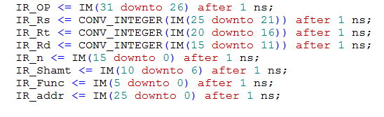
Now all that is required is to pass each of these signals along the pipeline for each instruction so that they are always available. Just as in Lab 6, we have a variable associated with the opcode. Here it is called IR_OP where the IR portion of the name is associated with the instruction registers that is between the instruction fetch and instruction decode stage. The same kind of association with IR is assumed by all the other signals listed above. The final task that needs to be taken into consideration is incrementing the program counter by 4. Now an instruction is ready to inter the ID stage.

The ID stage (instruction decode and register file read) is where we pass the program counter to the signal PCX. This saves the value of the program counter in case it is needed by an instruction in the EX stage. While we are in the ID stage we perform the register file read operations which is performed with the following code segment:
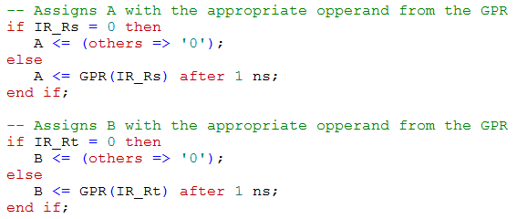
This segment of code does exactly what we have performed in state S1 in Lab 6. For both IR_Rs and IR_Rt if the address in the general purpose registers is the zero register, then either A or B or both will get the value ‘0’ as required by the instruction in the ID stage. Finally, just as in the ID stage we have to pass the required values held in the IR register to the IRX register. The required statements are following:
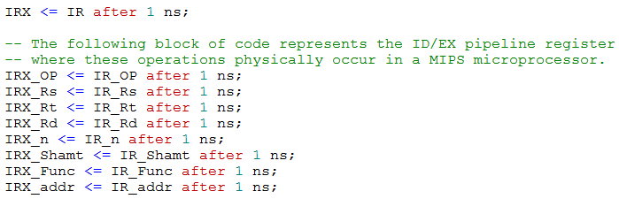
The association with each register with respect to the instruction register between the ID and EX stages is the same as the code segment discussed before. Now we have IRX_OP instead of IR_OP and the same is true for all the other registers whose values will be used in the EX stage.
The EX stage (execute and address calculation) is where all arithmetic and logical operations occur along with any required address calculations. Implementation of this stage is spread across three different processes. Any kind of instruction that should occur in the ALU will be carried out in a process called AluOperation and checking for forwarding and stalls occur in a process called Forwarding. In the process AluOperation the results of arithmetic and logical instructions get their results passed into a signal called ALU. Once that process stops executing ALU gets the value that it is holding passed to a register called ALUM. All other register transfer operations that do not occur in the AluOperation and Forwarding processes happen in the Pipeline process. Just as before, values in the registers between the EX and MEM stage will get passed along but we no longer need to keep track of the address held by the program counter for the current instruction. Forwarding will be discussed after we describe the basic structure of the pipeline process.
Once EX is completed we now have to implement the MEM stage which stands for memory access. Instructions that require memory access such as load word will have the results of its calculation placed in a register called ALUW. For this project we are concerned only with load word and how it is handled is described as follows:
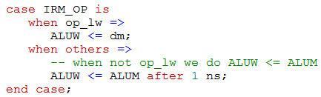
The code segment above tests the opcode of the instruction currently in the MEM stage of the pipeline. If the instruction is a load word then ALUW receives the address currently in data memory. When this happens ALUW will pass its value to the appropriate destination register in the write back stage. If the instruction is not load word then ALUW register receives the contents of ALUM.
The WB stage (write back) is where the general purpose registers get written to with the contents of ALUW. We implemented this stage with a case statement that decides which register will be used as the destination for the current instruction. The first case is used when the instruction is an R-Type instruction. Here we use the address in the Rd field of the instruction as the destination. If the instruction is an immediate type and requires us to write to the GPR, then the address of the Rt field is used as the destination.
Possible location to discuss forwarding
In order to allow instructions reads we needed to add a separate process called set_nIR. This process is sensitive to changes in the clock and when the internal reset signal called “ires” is equal to zero. The way this signal works is that if nIR or the internal not read signal called “iNIR” is equal to ‘1’ then we do not write. In general this will always happen when the clock is low but when the clock is high these signals are set to ‘0’ and an instruction read will occur. We need the ‘else’ portion for the main if statement and the nested if statement to take care of all other conditions that may occur where nir and iNIR is set to ‘1’.
Unlike the case in Lab 6 we now have code memory and data memory so we need a separate process to set the signals that allows us to read and write from data memory. We test for the same conditions with respect to the clock and the internal reset signal so when ires is ‘0’ and clk is ‘1’ then we enter a case statement that checks if an instruction is in execution that requires memory access.
First let us consider the case when the operation is a store word. Here we set nrd to ‘1’ and nwr to ‘0’ since we need nwr to be set to ‘0’ in order to allow us to store a word into data memory. We also pass the contents of the ALUM register to the signal line that has the data memory address called daddr. Data memory also will get passed the contents of the SMDR register as well. But if the operation is a load word then nrd is set to ‘0’ and nwr is set to ‘1’ so a memory read will be allowed. We also pass the contents of the ALUM register to daddr. For any other possible cases nrd and nwr will be set to ‘1’ and daddr and dm is set to high impedance.
We now switch topics to a discussion on the files used in this project. The project description states that we must use at least three files. The files that we used are the following:
- tb_pkips.vhd – This file contains the test bench which has support for reading code memory and reading and writing to data memory.
  - It also contains a process called Final_Dump that will write the final contents of data memory to a file called m_out.txt.
  - As specified we do not modify this file unless a request is authorized or requested to do so.
- pkips.vhd – The file that contains the pipeline that we formally discussed above.
- pkg_pkips.vhd – This file contains information that is necessary for the implementation of the pipeline.
  - It has a list of constants for opcode for all instructions that maybe needed and function codes for any functions that has the opcode of “00000”.
  - The package file also contains subtypes that maybe used is needed and constants for word size, memory size and the start addresses for code memory and data memory.
  - As specified we do not modify this file unless a request is authorized or requested to do so.

As noted above we do not change the test bench and package files unless required by the conditions listed above. There was a need to change the test bench by suggestion from the instructor. This change is listed below:
The original statement is as follows:
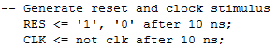
This change was required so that the clock will not start oscillating while the reset signal is still 1. This means the clock maintains a value of 1 while reset is 1, otherwise it oscillates once every 10 nanoseconds.
Changes were also made to the package so that we can use the NOP instruction. This instruction is an R-Type instruction and its function code is ‘000000’. When this pseudo instruction is encountered nothing happens since all values if the instructions are zeros. A new instruction called BNE was also added to support the need to do a branch not equal for the second test program.
For this project we are required to run two programs that are found in the files m_in.txt and m_in_ver2.txt. First we take a look at m_in.txt which is shown below:
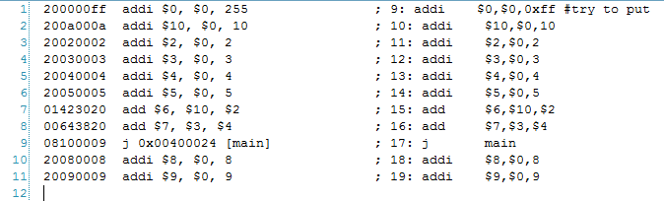
The purpose of this program is to test the pipeline so that we can make sure that it is working properly. This file does not contain any instructions that write to data memory thus no discussion of the contents of the output file called out.txt is required. The next text file called m_in_ver2.txt contains instructions that test the pipeline to see that we implemented stalls and forwarding. This file is shown on below:
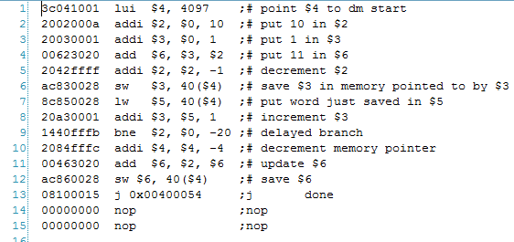
This text file tests the following requirements:
- Branch delay by two clock cycles that are caused by the instructions BNE and J.
- Stalls that are caused by load word.
- Forwarding.
When this program is executed the output file out.txt is created. The contents of out.txt is shown below:
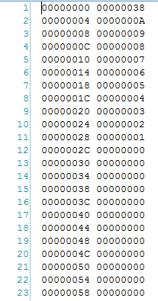
Results and Conclusions

